Max Silverstein

April 8, 2022

**Big Mountain Resort Ticket Price Report**

Big Mountain Resort is the premier ski resort in Montana, boasting scale, scenery and service that cannot be found anywhere else in the world. Big Mountain Resort’s leadership has expressed concern that they are not fully capitalizing on the resort’s impressive array of facilities, and have taken the most recent addition of a new chairlift as an opportunity to reexamine the resort’s ticket pricing strategy. To this end, our team was tasked with analyzing the winter resort market and determining a more optimal price point that will allow Big Mountain Resort to more effectively capitalize on and invest in its success. Our team has made the following determinations:

1. Big Mountain Resort can support a ticket price increase of at least $4; under current assumptions of ticket volume, this will increase expected revenue by $7 million at minimum, well over the seasonal operating costs of $1.54 million for the newest chair lift.
2. The resort can close its least-used run without any expected decrease in revenue.
3. Adding another chair lift to increase the resort’s maximum run descent by 150 ft. can support a $1.99 ticket price increase, with an expected revenue increase of over $3.4 million.

**Methodology and Results:**

To answer the question of how much Big Mountain Resort should charge for its tickets, our team decided to investigate the question of how the US ski resort market set ticket prices. In other words, the objective of our modeling was to predict how much a given ski resort would charge for a ticket based upon what we know about that resort.

The primary dataset we used for our analysis was the ski resort database provided by Database Manager Alesha Eisen, which describes a number of relevant characteristics of ski resorts across the United States that could be expected to have some influence on its price, such as run quantity, run size, numbers and types of lifts, and so on. We also utilized state population and geographical size statistics from the US Census bureau to capture some state-level market competition in the modeling.

With this data, we constructed a random forest model to predict a resort’s ticket price. This model outperformed a linear regression model and the national average ticket price in its predictive capability. The model expects Big Mountain Resort to charge $95.87 per ticket, with an expected error of $10.39. When compared to Big Mountain Resort’s current ticket price of $81, the model predicts that Big Mountain Resort could support a ticket price increase between $4.48 and $25.26.

Our team was also asked to evaluate four scenarios to either cut costs or increase revenue.

We assessed each scenario as a set of marginal changes and compared how ticket price (and therefore expected revenue) would change as a result. Assuming 350,000 customers over the season each customer purchasing 5 tickets on average, we found the following:

Closing the least used run resulted in no change in anticipated revenue, while closing additional runs resulted in the revenue decreases shown below:

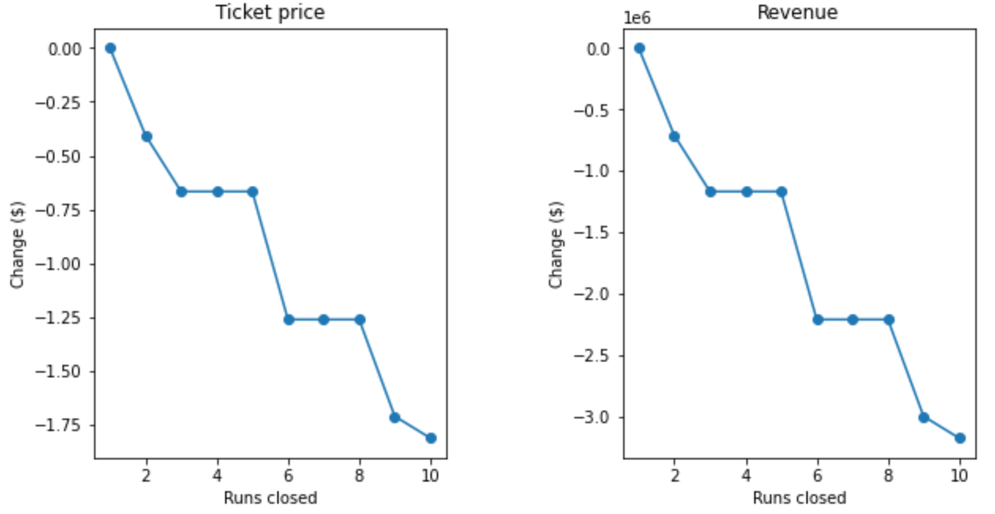

We found that adding another chairlift to increase the longest run’s length by 150 ft. would support a ticket price increase of $1.99 and a projected revenue increase of over $3.4 million. However, neither additional snow coverage nor further run length increases support price increases beyond those in Scenario 2.

**Interpretation and Recommendations:**

Although our model appears to justify a rather large ticket price increase, our team recommends caution in interpreting this model. As this model lacks important information on ticket sale volume and operating costs for other resorts, the predicted increase could be too high. However, when comparing Big Mountain Resort to the rest of the US ski resort market, we find that it is well above average in just about every respect that is associated with higher ticket prices in our modeling, which is consistent with the idea that the resort can support a higher ticket price. As such, we recommend starting with a more conservative increase of $4 per ticket; any additional price increases should be made gradually to gauge customer response.

Regarding the proposed scenarios, while closing the least-used run is not expected to lower revenue, further run closures are expected to lower revenue by millions of dollars. Once again, we recommend an incremental approach should the resort be interested in pursuing this strategy, testing customer response with each closure before considering the next. Installing another chair lift can be safely recommended if the operating costs are lower than the projected revenue increase of $3.4 million. However, further run length increases and snow making coverage are not expected to yield any benefit for the resort, and should not be pursued without additional information indicating otherwise.